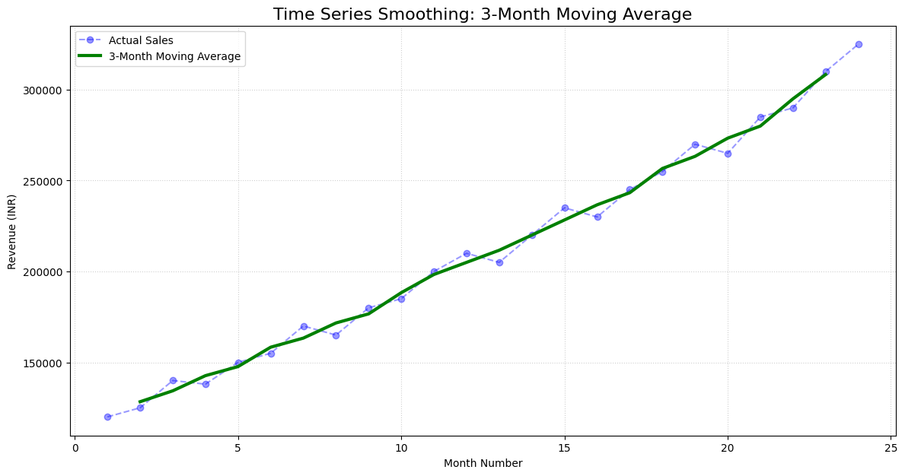

Executive Summary: 24-Month Sales Performance
This analysis evaluates our revenue trajectory from January 2024 through December 2025. By applying a 3-Month Moving Average, we have effectively filtered out short-term market "noise" to reveal the underlying health of our sales operations.

Key Insights for Stakeholders

1. Robust Long-Term Growth
The most critical takeaway is the strong positive correlation between time and revenue. While our initial manual calculations for a 6-month period showed a steady climb, the 24-month data confirms a sustained upward trend.
- Actual Sales: The blue dashed line shows the real-time volatility we experience month-to-month.
- Smoothed Trend: The green line (Moving Average) confirms that despite small dips (such as around Months 4, 8, and 16), the business is in a consistent expansion phase.

2. Seasonality and Volatility Patterns
- Cyclical Dips: We notice recurring minor pullbacks nearly every 4–6 months. These likely represent seasonal fluctuations or standard procurement cycles.
- Year-Over-Year Comparison: Revenue at the end of Year 2 (Month 24) is significantly higher than Year 1, indicating that our growth is not just seasonal but structural.

Strategic Suggestions for Profitable Sales
To turn these insights into higher profitability, I recommend the following actions:

A. Inventory and Resource Optimization
Since the green line provides a "smoothed" forecast, we can use it to predict baseline demand.
- Action: Align staffing and inventory levels with the Moving Average rather than the volatile monthly peaks. This prevents over-leveraging during temporary spikes and stockouts during dips.

B. Targeted Marketing During "Dip" Months
The plot shows consistent, predictable periods where the blue line falls below the green line (e.g., Months 8, 13, and 16).
- Action: Launch promotional campaigns or loyalty discounts 30 days prior to these identified "dip" periods to flatten the curve and maintain consistent cash flow.

C. Capitalizing on Momentum
The steepening slope toward the end of 2025 suggests our market share is accelerating.
- Action: Now is the ideal time to consider price optimization or upselling higher-margin services, as the data shows customers are increasingly receptive to our offerings.

Summary for Project Manager
"Our current trajectory is healthy and predictable. The moving average confirms we are outperforming our baseline every quarter. My recommendation is to stabilize our supply chain around the green trend line and focus our next marketing push on the recurring 4-month cyclical dips to maximize year-end profitability."

